MOBBERLEY PARISH COUNCIL
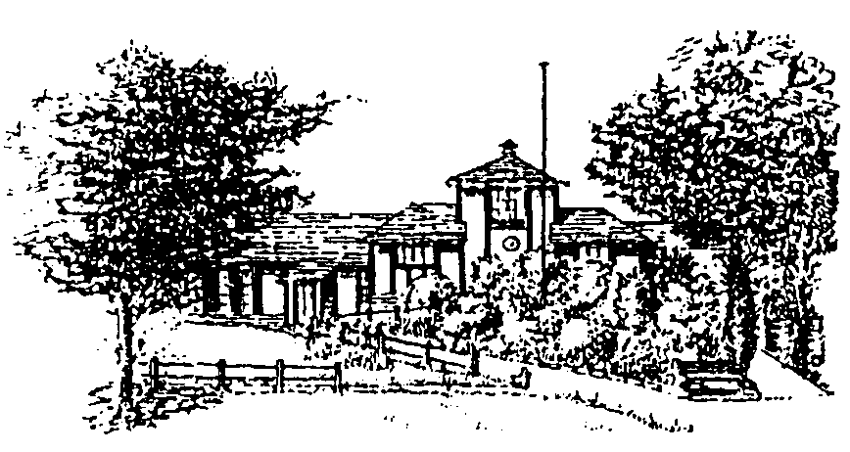
Rajar Building
Town Lane
Mobberley
Cheshire
WA16 7GH
Mobberley Parish Council Strategic Plan 2022 – 2025.
Adopted on

- Introduction.
This is the first Mobberley Parish Council Strategic Plan and it sets out the vision for the Parish Council for the next three years. The aim of the strategic plan is to give Mobberley residents and businesses a clear understanding of what the Parish Council is trying to achieve and the work that it undertakes for the village. The strategic plan is a live document that will be regularly reviewed and used to drive the annual budget process, to plan activities and to enable the Parish Council to monitor its progress.
The Strategic Plan is based on the council’s understanding of the communities needs gained from day-to-day involvement with residents, local businesses and key organisations like Cheshire East Council.
The document will be made available via the Parish Council website and hard copies will be made available on request from the Clerk. We value residents’ input into this live document and actively encourage feedback on the plan.
The Parish Council will monitor the document on an annual basis and monitor progress to keep the document relevant and up to date. The review will take place at the annual meeting of the council and residents will be welcomed at the meeting to share their views.

- Mission Statement.
To represent the views and interests of Mobberley residents, to protect and enhance the rural character of the village and its flora and fauna. To contribute to a sustainable and inclusive community. A sustainable community is one which retains and improves what is good, whilst embracing the positive aspects of changes or developments for the long-term benefit of the whole community

- Objectives.
- To provide high quality, efficient, cost-effective and sustainable services.
- To assist in the creation of a socially inclusive and economically viable community embracing all residents irrespective of age, culture, income, race or religion and which seeks to develop their well-being knowledge, understanding and mutual co-operation.
- To provide channels for the views and expressions of the Local Community and to be responsive to its needs and aspirations.
- To promote and encourage the provision of leisure, social, recreational and community educational facilities in the Parish which are appropriate to the normal activities of a rural Parish.
- To develop partnership and agency working with the public and private sectors in terms of resources and finance for the benefit of the community.
- To liaise with and support Local Community groups and Associations.
- To recognise climate change and implement measures consistent with carbon neutrality in 2025.
- To support ecological enhancement and biodiversity.

- Principles:
In all actions the council will take into account, and where appropriate act in accordance with the principles enshrined in the relevant legislation and best practice for:
- Health and safety
- Equal Opportunities
- Best Value
- Crime and disorder
- Disability Discrimination Act
- Age Discrimination Act
- Local Council Awards Scheme
- Environmental, Heritage and Planning Legislation
- General Date Protection Regulations.

CATEGORY | TOPIC | ACTION | OBJECTIVE | TIMESCALE | BUDGET
THEME 1 | Website | Ensure it is kept up to date and  complies with WCAG 2.1. | To improve communication between the parish council, local residents and businesses by: Promoting the activities of the council. Informing residents about local and county wide issues.  Improving the effectiveness of the Parish Council. | Ongoing | £300 per annum
PARISH COUNCIL
GOVERNANCE
Communication
 | Newsletter and Annual Report | Ensure a minimum of 10 newsletters are published annually.  Newsletters to be posted on the Parish Council website. | To provide a regular newsletter about the council’s activities and other information of local interest. To promote Mobberley’s local business community through paid advertising. | Ongoing | £3,000 annual printing cost, offset with £2,500 annual advertising revenue.
 | Parish Council meetings | Publish agendas of all full council and committee meetings, supporting information and minutes on website.  Post all agendas on notice boards. | To provide information about the council’s decisions and encourage members of the public to attend council meetings and participate in the public session. | Ongoing | Included in  Clerk’s duties.
 | Local Council Award Scheme | To ensure the council meets the standards set by the sector. To register for the NALC Local Council Award Scheme. | To work towards a ‘Quality’ Council Award in recognition of the work that the council does in the community. | Start 2022 | Included in  Clerk’s duties.  The cost to register is £50

CATEGORY | TOPIC | ACTION | OBJECTIVE | TIMESCALE | BUDGET
Theme 2  COMMUNITY | Upgrade of Victory Hall Kitchen Facility | Work with the Trust Committee to support the fundraising efforts to upgrade the kitchen facility at the Victory Hall. | To improve the building and its amenities. | Ongoing | £5,000 in Earmarked Reserves.
 | Upkeep of the Rajar Community Building. | To produce a comprehensive maintenance and improvement plan for implementation. | To maintain and manage the building for future community use. | Ongoing | £7,500 To be set aside in Earmarked Reserves.
 | To improve and  enhance local facilities. | To provide grant funding to local groups and charities. | To increase social capacity for local voluntary groups and the wider community. | Annually | £2,500 annual budget.
 | To fund Village Pride initiatives | To fund four benches along Hall Lane. | To maintain the appearance of the village for the enjoyment of residents and visitors.  The benches will enable elderly residents to walk to the shops and centre of the village. | Annually | £6,500 annual budget.  £5,300 to fund the benches.
 | Community Meadow | To monitor the community meadow regularly for maintenance issues. To mow the path on a twice-yearly basis. | To ensure the community meadow is maintained for the benefit of the community, both now and for future generations. To enhance the meadow’s biodiversity and create a wildlife rich environment. | Annually | £2,500 budget for grass cutting and tree maintenance.  £20,000 to construct an accessible path around the pond.
 | Local policing | To work with the PCSO to provide monthly reports to the full council of reported crimes in the area. | To raise residents’ awareness of any patterns in repeat crimes in the area. | Monthly | No budgetary implications
 | Garage Plots | To transfer the Cheshire East Council garage sites at Oldfield Road, Tatton Stile and Townfield Road to the Parish Council. | To ensure the future use of the garages for the local residents. | Ongoing | £3,000 for solicitors fees.
 | Climate Emergency | To work with the community to help promote environmental awareness and to declare a climate emergency. | To ensure that Mobberley is doing all it can to raise awareness of the climate emergency. | Ongoing | No budgetary implications.
 | Climate Emergency | To put a plan together to improve the environmental credentials of the Rajar Building. | The Council is doing all it can to carry out their work in a more sustainable way. | Ongoing | No budgetary implications if grants are available.

CATEGORY | TOPIC | ACTION | OBJECTIVE | TIMESCALE | BUDGET
Theme 3  TRAFFIC AND TRANSPORT  Highways | Highways issues | Publish useful information on the Parish Council’s website. | To assist people to report highways issues directly to Cheshire East Council (the highway  authority). | Ongoing | No budgetary implications
 | Traffic calming schemes | Monitor road safety issues and research potential funding for an average speed camera on Knutsford Road. | To seek solutions to speeding and improve road safety. | Ongoing | Potential match funding applied for with the PCC. MPC to allocate £5,000 for an average speed camera.

CATEGORY | TOPIC | ACTION | OBJECTIVE | TIMESCALE | BUDGET
Theme 4  HOUSING AND HEALTH | Supporting health and wellbeing | To support adequate affordable housing and health provision. | To ensure that people have access to social care, health care and good living standards. | Ongoing | No budgetary implications.
 | Defibrillators | To assess the need for defibrillators in the community and to research grant awards for funding hem. | To ensure the local community has adequate access to a defibrillator. | One year. | No budgetary implications if grants are available.
CATEGORY | TOPIC | ACTION | OBJECTIVE | TIMESCALE | BUDGET
Theme 5 PLANNING | Future development within the parish. | Respond to planning applications and policy review representing the views of the local community.  Encourage residents to respond to consultation to ensure their views are taken into consideration. | To continue to comment on all key strategic planning and consultations that affect the parish to ensure that, through the Parish Council, the views of the local community form part of the decision-making process. | Ongoing | No budgetary implications.
 | Understanding planning policy | Councillor training. | To ensure the Parish Council’s responses are based on material consideration. | Ongoing | Annual cost of training £200.

Budget Implications

OBJECTIVE | 2021/2022 |  | 2022/2023 |  | 2023/2024
 | CAPITAL | REVENUE | CAPITAL | REVENUE | CAPITAL | REVENUE
Theme 1 | BUDGET
Continue to review and improve website |  | £300 |  | £300 |  | £300
Continue to publish parish newsletter and Annual Report |  | £500  (£3,000 printing offset with £2,500 advertising) |  | £500 |  | £500
Local Council Award Scheme |  | £50 |  | £50 |  | £50
Theme TOTAL |  | £850 |  | £850 |  | £850
Theme 2
Upgrade of Victory Hall Kitchen Facility |  |  | £5,000
Upkeep of the Rajar Community Building |  | £7,500 |  | £7,500 |  | £7,500
To improve and enhance local facilities |  | £2,500 |  | £2,500 |  | £2,500
To fund Village Pride Initiatives |  | £6,500 |  | £6,500 |  | £6.500
Solicitor fees for garage plots |  |  | £3,000
Community Meadow |  | £2,500 |  | £20,000 |  | £2,500
Hall Lane Benches |  |  | £5,300
Theme TOTAL |  | £19,000 |  | £47,800 |  | £19,000
Theme 3
Average speed camera |  |  |  | £5,000
Theme TOTAL |  |  |  | £5,000
Theme 5
Understanding Planning Policy |  | £200 |  | £200 |  | £200
Theme TOTAL |  | £200 |  | £200 |  | £200

Approved:
Next review date:

